Tricia Martineau Wagner, a nationally renowned author & presenter, is an experienced elementary teacher and reading specialist. As a well versed and entertaining speaker she brings history to life! Ms. Wagner enjoys conducting classroom presentations for grades K - 8.

“African American Women of the Old West” child-interactive presentation:

The author will:

- Come dressed in period clothing
- Give a history of settling the Old West (1840s – 1880s)
- Talk about the contributions of black women of the West
- Explain how a book is published
- Inspire students to write
- Stress the importance of editing & rewriting their own work
- Bring America’s past to life and excite students to read more
- Q & A

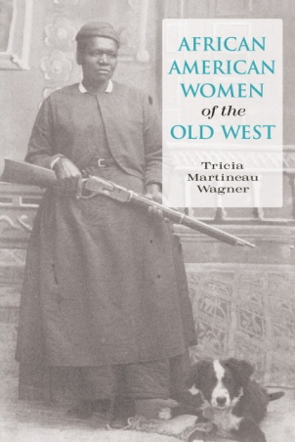

Highlights of school presentations:

- The interactive, hands-on presentation shares 100 pioneer artifacts to handle including: using clothes washing equipment, cooking kettles, butter churners, irons, tin-type photographs, quilts, and period clothes to try on.
- Power Point presentation on the Old West (45-min)

BOOK SIGNING: Book order forms will be sent home prior to the event. Ms. Wagner will bring the personally autographed books with her to your school. (Late book orders are always accepted.)
An autographed book will be gifted to your school library.

Number of presentations in one school visit: up to 4

Large school assembly: Small group assembly:
(200 students) 60 minutes (60 students) 60 minutes

$300 for the 1st presentation $200 for the 1st presentation
$300 for the 2nd presentation $200 for the 2nd presentation
$200 for the 3rd presentation $175 for the 3rd presentation
$200 for the 4th presentation $175 for the 4th presentation

Visit Ms. Wagner’s website: www.authortalk.org. For additional information or to schedule an event please contact the author directly: tricia@authortalk.org

Additional program presentations that coordinate with her other books include: 50 Wacky Things Animals Do / North Carolina, the First Golden State / It Happened on the Underground Railroad / It Happened on the Oregon Trail / Black Cowboys of the Old West. [The author also conducts a hands-on, experiential based program: A Child’s Life out West.]

Thank you in advance for forwarding this educational opportunity to other schools/educators.

educators.

