Tricia Martineau Wagner, a nationally renowned author & presenter, is an experienced elementary teacher and reading specialist. As a well versed and entertaining speaker she brings history to life! Ms. Wagner enjoys conducting classroom presentations for grades K - 8.

“It Happened on the Underground Railroad” child-interactive presentation:

The author will:

- Come dressed in period clothing
- Give a history of the Underground Railroad (1830s – 1865)
- Educate students on black agency of the UGRR
- Talk about daring escape stories from her book
- Explain how a book is published
- Inspire students to write & stress the importance of editing
- Q & A

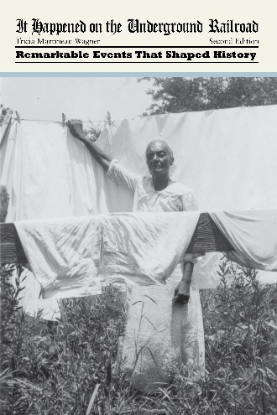
Highlights of school presentations:

- The interactive, hands-on presentation shares 100 artifacts to handle: tin-type photographs, cotton plants, slave artifacts, abolitionist newspapers, and period clothing to try on. Students can climb into replicas of items used in escape missions such as Henry “Box” Brown’s shipping crate he used to mail himself north and an old steamer trunk a slave hid in during a sea escape.
- Voice recordings from slaves for students to listen to and actual slave quotes to read
- Power Point presentation on the Underground Railroad (45-min)

BOOK SIGNING: Book order forms will be sent home prior to the event. Ms. Wagner will bring the personally autographed books to your school. (Late book orders are always accepted.) An autographed book will be gifted to your school library.

Number of presentations in one school visit: up to 4

Large school assembly: Small group assembly:
(200 students) 60 minutes (60 students) 60 minutes

$300 for the 1st presentation $200 for the 1st presentation
$300 for the 2nd presentation $200 for the 2nd presentation
$200 for the 3rd presentation $175 for the 3rd presentation
$200 for the 4th presentation $175 for the 4th presentation

Visit Ms. Wagner’s website: www.authortalk.org. For additional information or to schedule an event, please contact the author directly: tricia@authortalk.org

Additional program presentations that coordinate with her other books include: 50 Wacky Things Animals Do / North Carolina, the First Golden State / It Happened on the Oregon Trail / Black Cowboys of the Old West / African American Women of the Old West. [The author also conducts a hands-on, experiential based program: A Child’s Life out West.]

Thank you in advance for forwarding this educational opportunity to other schools/educators.

